2013 June

한국사회책임투자포럼 뉴스레터 114호 2013. 6. 17(월)

**Column | 취봉의 눈(目) – 양춘승 상임이사**

**원전비리와 ENRON 사건**

원자력 발전소에 납품된 부품의 시험 성적서를 위조한 사건을 둘러싸고 ‘소 잃고 외양간 고치는’ 일이 벌어지고 있다. 큰 인명 피해로 이어지기 전에 비리가 알려져 그나마 다행이지만, 이 기회에 엄정한 책임 규명과 관련자 처벌, 그리고 항구적인 대책이 마련되지 않으면……

(http://www.kosif.org/board/bbs/board.php?bo_table=interview&wr_id=267)

**Event**

**(아래 배너는 수정 예정)**

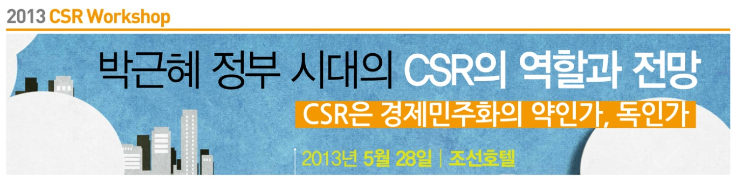

(http://www.kosif.org/board/bbs/board.php?bo_table=notice&wr_id=182)

**Event 후기**

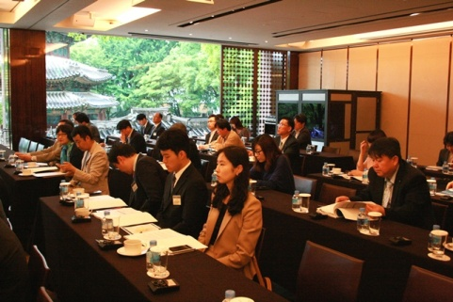**2013 CSR Workshop**

**박근혜 정부시대의 CSR의 역할과 전망**

**- CSR은 경제민주화의 약인가, 독인가? –**

http://www.kosif.org/board/bbs/board.php?bo_table=seminar&wr_id=17

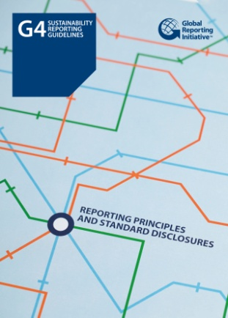**Report**

**GRI G4**

**Sustainability Reporting Guidelines**

발행일: 2013. 5 / 발행처: GRI

The GRI Sustainability Reporting Guidelines (the Guidelines) offer Reporting Principles, Standard Disclosures and an implementation Manual for the preparation of sustainability reports by organizations, regardless of their size, sector or location. The Guidelines also offer an international reference for all those interested in the disclosure of governance approach and of the environmental, social and economic performance and impacts of organizations.

<http://www.kosif.org/board/bbs/board.php?bo_table=interior&wr_id=433>

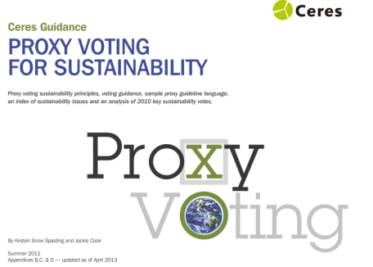

**Proxy Voting for Sustainability**

발행일: 2013. 5 / 발행처: CERES

This report serves as a resource guide to help global investors respond to environmental, social and governance (ESG) issues that are increasingly the subject of shareholder resolutions filed with U.S. publicly held corporations. This first-of-its-kind report lays out four concise sets of principles on governance, social issues, general sustainability and environmental performance to guide investors’ voting on specific resolutions addressing these topics.

(http://www.kosif.org/board/bbs/board.php?bo_table=interior&wr_id=431)

**SRI news**

- 대규모 공사 낙찰자 선정할 때 사회적 책임 이행도 고려

(http://www.kosif.org/board/bbs/board.php?bo_table=latest&wr_id=1651)

- 신제윤 "全금융권 대주주 적격성 심사…지배구조 투명성 제고"

(http://www.kosif.org/board/bbs/board.php?bo_table=latest&wr_id=1652)